Benny Iko

7/26/2021

SWEN 603 9040 Modern Software Methodologies

Crystal methodology critique

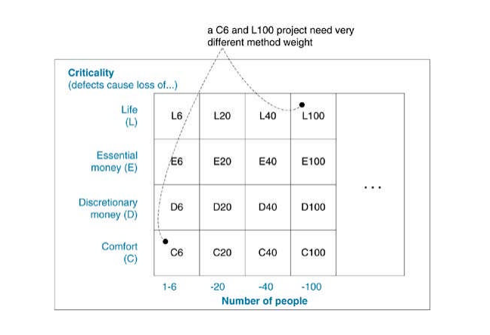

Described by Alistair Cockbun, Crystal is a group of Agile/lightweight methodologies that may be identified using a range of different colors; each color presents a varying level of complexity. In ascending order of complexity, here are a few of the known variations: Clear, Yellow, Orange, Red, Maroon, Blue and Violet. These different versions of Crystal contain increasing process ceremony in terms of defined and ordered steps, documents, and reviews as a function of staff size, criticality, and project priority. While acknowledging the necessity of an iterative lifecycle, with Crystal methods, Cockburn stresses the importance of "peopleware"; that is, issues over process: education, communication, etc. His idea of software development shows this emphasis: "…a cooperative game of invention and communication." Ideally, this software life cycle is aimed at small development teams of 6-8 co-located developers, and non critical systems. This methodology focuses on efficiency, components of project safety, habitability, and most notably, people. Implementation of this paradigm includes seven key properties: frequent delivery of usable code to others, reflective improvement, osmotic communication, personal safety, focus, easy access to expert users, automated tests, configuration management, and frequent integration. However, I would like to reiterate the heavy emphasis placed upon communication among persons involved with the project. Crystal shares this trait, as well as others with other Agile methods, specifically XP or Extreme Programming. The creators of XP and Crystal realized that human factors such as simplicity, enjoyment, short-term reward, and peer pressure, are important contributing factors to create the foundation for sustainable self-discipline with practices.

The seven properties of Crystal Clear make it a viable solution for select software projects. Frequent delivery of code, reflective improvement and ebay access to expert users are the ideals that I’d like to draw more attention to. The single most essential property of any project, large or small, is the delivery of runnable, tested code to real users intervally. There are many pros to frequent delivery, including: critical feedback, reflection, maintained focus for developers, and elimination of indecision. The development team also receives a morale boost through such accomplishments. To achieve this, two months is a safe time period for an iteration; any period longer than four months may not offer this safety. This property of Crystal methodology makes it well suited for web based applications. Sometimes software is deployed to the full set of users at the end of each iteration for production use. This solution is also practical when the user group is relatively small. This life cycle is not intended for environments that cannot handle software updates frequently. When users cannot accept software updates that often, then there is a dilemma. If software teams deliver the system frequently, users will get annoyed with them. On the contrary, if they don't deliver frequently, there is a possibility for issues with integration or deployment. Chances are that they will encounter that problem when it is too late, at the moment of deploying the system. A different approach, like Waterfall may be more suitable for environments that are not as accepting of change. Something I personally find remarkable about Crystal Clear is its flexibility. The methodology takes into account the fact that people, technology, and the assignment change over the course of a project. As a result, how a team operates and the conventions the team uses need to change to match. Crystal Clear leaves many details unstated, and left for the team to finalize. To achieve reflective improvement, groups have a myriad of options at their disposal. It can be every few weeks, once a month, or twice per delivery cycle, that people get together in a reflection workshop or iteration retrospective to discuss how things are working. Most interesting to me is the amount of experimentation that is allowed. Whatever the frequency, meeting format, and technique used, successful teams hold this discussion periodically and try out new ideas. Teams may try, in different forms: pair programming, unit testing, test-driven-development, single-room versus multiple room seating, various levels of customer involvement, and even differing iteration lengths. These are all proper variations within Crystal Clear. With the exploratory nature of this paradigm, it is expected that they will try new ideas as opposed to continuing to use the starter conventions. Continued access to expert user(s) provides the development team with a place to deploy and test the frequent deliveries, rapid feedback on finished product quality and design decisions, and up to date requirements. In 1995, researchers published results showing how essential it is to have direct links to expert users; even one hour a week of access to a real and expert user is extremely valuable. While the first hour is the most crucial, the more hours each week that an expert user is available to a team, the more advantage they can take of that proximity. There are different methods for user access that are appropriate for Crystal Clear: weekly or semi weekly user meetings with additional phone calls, one or more experienced users directly on the development team, and sending the developers to become trainee users for a period.

